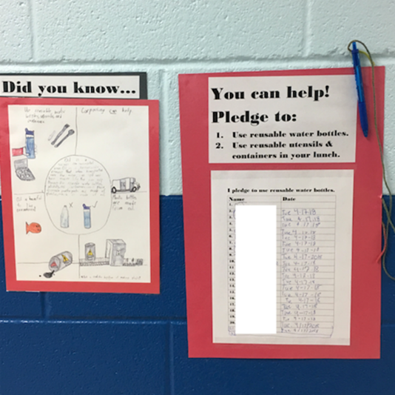
Ms. Johnson’s fourth grade class spent last month educating their school community about the environmental impacts of using too much petroleum. In science, the teacher and students had been learning about energy systems, circuits, and energy-related problems related to renewable and non-renewable resources. After deep conversations about trade-offs of different sources of energy, the class discovered a problem that they wanted to solve. The plastic water bottles that they bring from home, use and then throw away are made from petroleum formed hundreds of millions of years ago. The class launched into action to share their new knowledge. Small groups worked together on different aspects of the project. One group made “Did you know?” posters to hang in the cafeteria to teach students about petroleum and plastic. Another group wrote an announcement about the project for morning announcements. Yet another prepared a pledge for students to sign if they would commit to using reusable water bottles. More than 300 students signed the pledge, all of the students in the classroom switched to reusable water bottles and the class bubbled with excitement about their progress and impact.

Imagine Ms. Johnson’ classroom experience compared to one in which a teacher just lectures about renewable and non-renewable energy sources or passes out worksheets with lists of science vocabulary terms. Which classroom would teach you more science? Which classroom would help you understand ways that you can make a difference in your community? Research from this project generated promising evidence that Connect Science is a better approach.

Ms. Johnson was one of 90 teachers who learned Connect Science as part of a four-year project led by a team of researchers and developers at the University of Virginia, Arizona State University, and Harkins Consulting, LLC. Educators are looking for evidence-based curricular approaches that promote whole-child learning. Further, educators are seeking ways to engage students in authentic, meaningful work while also meeting required standards. Our team worked to meet educators’ needs by developing Connect Science. The initial research on Connect Science suggests its efficacy.
Connect Science (CS) guides teachers through an 8-step service-learning experience following the KIDS as Planners Framework (Harkins Consulting, 2011). Teachers began the sequence by teaching students social and emotional skills to prepare for collaborative work and introducing the idea of civic engagement so students understood how they could make a difference in their community. For instance, students learned about listening to each other and communicating respectfully.

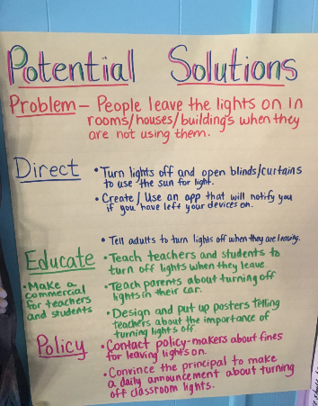
Early in the sequence, the class learned how people could use their knowledge to identify needs in their community and create change. Then, teachers launched into a series of Next Generation Science Standard (NGSS)-aligned science lessons. Students learned about circuits, energy systems, energy production and energy-related problems related to renewable and non-renewable resources. Students began to discover the problems that we face given the reliance on non-renewable energy sources in the U.S. Lessons guided students to discuss and debate the pros and cons of different energy sources using their newly learned social and emotional skills.

Teachers used a differentiated approach to assess student learning. Then, classes selected energy-related problems that mattered to them, and designed a project to deepen their learning as they took action as engaged citizens. Projects focused on educating others, shifting policy, or taking direct action. (Common projects included energy fairs, all-school energy-use challenges, energy reduction efforts, etc.) Throughout, the class monitored progress, assessed impact, and reflected.
Teachers participated in five days of PD and follow-up coaching. Teachers received a manual and science materials to implement Connect Science over a 15-20 week period. The project team conducted a randomized controlled trial involving 41 classrooms at 25 schools (20 intervention, 21 waitlist control) and 868 students (423 in the intervention group). Two research questions were addressed: 1) to what extent did Connect Science impact teaching practices and 2) to what extent did Connect Science impact student outcomes? Results showed that teachers in the Connect Science group used more NGSS and Connect Science practices. For instance, teachers were more likely to support student critique, explanation and argument as well as access students’ prior knowledge in the classroom. Students in Connect Science classrooms had higher science achievement and some aspects of civic engagement (energy attitudes and behaviors). Further, students in Connect Science had higher social skills than those in the control group if their teachers implemented Connect Science fully.

Findings from this initial study shows that Connect Science shows promise for promoting students’ academic learning as well as civic engagement. Results suggest that when students are given a chance to work together and apply their new knowledge and skills to a problem that they care about, deep learning can result.

